COSC 4377 – Networking - Kevin B Long

# interlocking-uh-m-186.eps

# **Homework #2**

Due 11:59pm, Sunday, 18 February, 2018

100 points total

Multiple submissions accepted.

Joshua Nguyen

________________________________________________________

Name

______________1304578_____________

PeopleSoft ID

1. (10x2 pts) Access the HTTP Delay Estimation simulator at <https://media.pearsoncmg.com/aw/ecs_kurose_compnetwork_7/cw/content/interactiveanimations/http-delay-estimation/index.html>

This simulator shows how a web page and its objects are delivered from a server to a client via HTTP by a web server. For this simulation, choose 4 objects and any non-zero per-object transmission delay.

1. Which connection type always requires the greatest total time to retrieve the page and its objects?

**Non-Persistent Connection**

1. Which type requires the least amount of total time?

**Persistent Connections with Pipelining**

For the following four questions, there are 4 objects being transmitted, and when we have the chance we will choose 4 parallel connections.

1. Which type of connection does this represent (assume 4 objects)? **Persistent Connections with Pipelining**

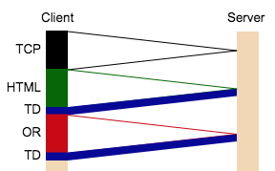

1. Which type of connection does this represent (assume 4 objects)? **a non-persistent connection with parallel connections**

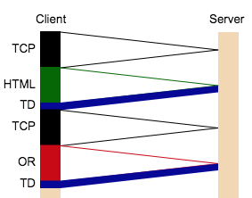

1. Which type of connection does this represent (assume 4 objects)?

**Non-Persistent Connection**

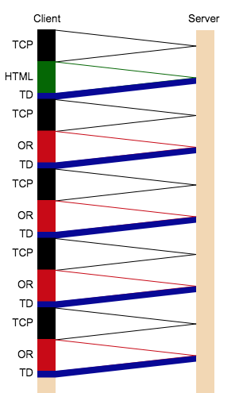

1. Which type of connection does this represent (assume 4 objects)?

**Persistent Connections without Pipelining**

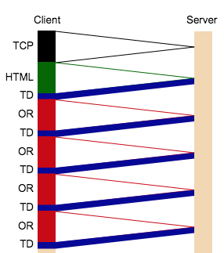

1. What do the persistent connections eliminate from the transmissions?

**It eliminates and reduces network latency and any CPU/memory usage of all peers from established TCP/IP connection**

1. Compare a persistent connection with pipelining to a non-persistent connection with parallel connections with as many parallel connections as you can get. What part of the transmission just can’t be eliminated from the non-persistent connection? **TCP, TD**
2. Draw a trace for an html page and 6 objects using a persistent connection with pipelining by marking over the light grey lines, as many as required. Use TCP, HTML and OR labels on the left. You can ignore writing TD for Transmission Delay. However, please do assume the transmission time of web page objects are substantial and noticeable. Therefore, you should darken those lines.

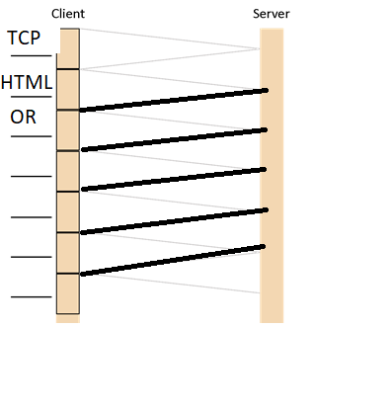

1. Despite the requirement in HTTP/1.1 that servers support pipelining, only one major browser supports pipelining by default. What is it, and briefly why is it disabled in all other major browsers? You’ll find the answer in Wikipedia’s page on HTTP pipelining.

**Opera, Google Chrome used to support pipelining, but it has been disabled due to bugs and problems, Internet Explorer 8 does not support it due to buggy proxies and head of line blocking. Pipeline is disabled by default because it is to avoid issues with misbehaving servers.**

1. (5x1 pts)What is the unit of information called that each layer produces in the TCP/IP model? None of the answers are “packet”.
2. **Application layer: login host**
3. **Transport layer: TCP segment**
4. **Network layer: IP datagrams**
5. **Data Link layer: cyclic redundancy check (CRC)**
6. **Physical layer: frame**
7. (8x2 pts) Use Wireshark to capture a trace to <http://www.uh.edu>. Filter for HTTP, and export it using Wireshark’s File menu. I had the best results choosing Export Packet Dissections as Plain Text.

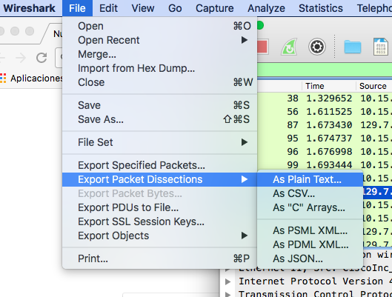

Throw all the packet traces away except the very first GET and its response. If you click on the first GET, Wireshark will give you the number of its corresponding response. Then you know what to toss from your export. Paste the resulting pair of packets below as plain text, and then answer the following questions, highlighting in your packets where you found the answers. If you use Word, you can just use its built-in highlighting tool.

-----Paste your two packets here. -------

**No. Time Source Destination Protocol Length Info**

**27 5.048289 192.168.1.101 129.7.97.54 HTTP 627 GET / HTTP/1.1**

**Frame 27: 627 bytes on wire (5016 bits), 627 bytes captured (5016 bits) on interface 0**

**Ethernet II, Src: Giga-Byt_df:4a:22 (90:2b:34:df:4a:22), Dst: Cisco-Li_e9:72:c5 (00:16:b6:e9:72:c5)**

**Internet Protocol Version 4, Src: 192.168.1.101, Dst: 129.7.97.54**

**Transmission Control Protocol, Src Port: 60585, Dst Port: 80, Seq: 1, Ack: 1, Len: 573**

**Hypertext Transfer Protocol**

**No. Time Source Destination Protocol Length Info**

**90 5.710796 192.168.1.101 129.7.97.54 HTTP 695 GET /cdn/anchorme/js/anchorme.min.js?_=1519011685344 HTTP/1.1**

**Frame 90: 695 bytes on wire (5560 bits), 695 bytes captured (5560 bits) on interface 0**

**Ethernet II, Src: Giga-Byt_df:4a:22 (90:2b:34:df:4a:22), Dst: Cisco-Li_e9:72:c5 (00:16:b6:e9:72:c5)**

**Internet Protocol Version 4, Src: 192.168.1.101, Dst: 129.7.97.54**

**Transmission Control Protocol, Src Port: 60585, Dst Port: 80, Seq: 574, Ack: 18233, Len: 641**

**Hypertext Transfer Protocol**

1. What is the URL of the document requested by the browser as shown in the packet?

___________/**cdn/anchorme/js/anchorme.min.js?_=1519011685344**____________________________________________________________

_______________________________________________________________________

1. What version of HTTP is the browser running?

___________________________________**HTTP.1.1____________________________________**

_______________________________________________________________________

1. Does the browser request a non-persistent or a persistent connection? What makes you say that?

____________ ***Persistent Connections without Pipelining*__IT is the require only one TCP protcol**_________________________________________________________

_______________________________________________________________________

1. What is the IP address of the host on which the browser is running? Is that part of the HTTP data?

_______________ **129.7.97.54____Yes, it is the destination ip address of UH website____________________________________________________**

1. What type of browser initiates this message?

____**_______Google Chrome is being used. IT doesn’t used any pipelining____________________________________________________________**

_______________________________________________________________________

1. Why is the browser type needed in an HTTP request message?

______________________________________**Each browser especially Google Chrome is unique in it functions and features for using and needed HTTP request message________________________________**

_______________________________________________________________________

1. Verify that your browser supports http/2 by going to <https://http2.akamai.com/>. Copy and paste the message near the top of the page that states whether or not you are using HTTP/2. Ignore any comments about server push.

_______________________________ **You are using HTTP/2 right now! (server-push is NOT used)__________________________________________**

1. Now restart Wireshark’s capture and navigate to [www.google.com](http://www.google.com). Now that you know your browser uses HTTP/2, filter for “http2”. You will come up empty. Why?

**It comes out empty because google.com uses https as a further security to protect their web search engine.**

The diagram here might help you understand, from here: <https://caniuse.com/#search=http%2F2>. What do you see the HTTP/2-capable browsers all have in common that explains why you aren’t seeing any http2 packets in Wireshark?

**All of the browsers only supports HTTP2 over TLS (https) and nly supports HTTP2 if servers support protocol negotiation via ALPN**

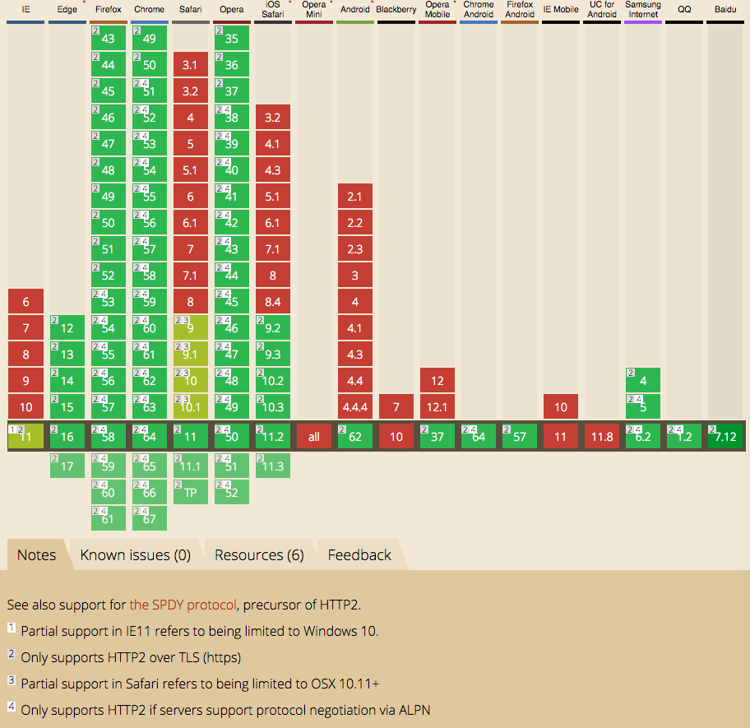

_________________________________________________________________________

1. (6x1 pts) Not all devices process all layers all the time.
   1. Which layers in the Internet protocol stack does a router process?

_______________________________________________________________________

* 1. Which layers does a link-layer switch process?

_______________________________________________________________________

* 1. Which layers does a host process?

_______________________________________________________________________

* 1. If we have a device that receives an electrical signal on a twisted pair cable, filters off high frequencies to remove noise, and amplifies the signal strength, but is completely passive and otherwise knows of the meanings of the signals, at what layer does it operate?

_______________________________________________________________________

* 1. A router offers a way for an administrator to log in and manage the device. Code to run a secure shell has been added to the router, and the administrator can log into the router remotely and change the configuration. This is an example of the router running what layers of the stack?

_______________________________________________________________________

* 1. We want to build a device that runs only the application layer. Is this possible?

_______________________________________________________________________

1. (2x5 pts) Equation 1.1 gives a formula for the end-to-end delay of sending one packet of length L over N links of transmission rate R which ignores propagation delay:

$$d_{end-to-end}=N\frac{L}{R}$$

Consider a network 2 two hosts, 2 switches (and thus 3 links), and 10 packets.

At time 0, all 10 packets are at Host A.

L/R is the transmission delay, so we have to wait that amount of time for a packet to leave a device.

Therefore, at time 1*L/R, one packet has moved to the first switch, and 9 packets remain at Host A. At time 2*L/R packets have advanced one position, but none have reached Host B yet:

Not until time 3*L/R does a packet arrive at Host B. 10-1=9 packets remain in transit or awaiting transmission.

Also, once the first packet arrives, the 2nd packet is at S2, only one transmission (L/R) away from Host B. Then the 3rd packet will be at S2, one transmission away. So after the first packet arrived at Host B, we need 9 more rounds of L/R to bring the remaining packets to Host B.

1. Can you generalize the equation to 2 hosts, N links (and so N-1 network devices), and P packets?

_______________________________________________________________________

_______________________________________________________________________

1. If we add propagation delay *dprop* to each link, can you generalize the equation further?

_______________________________________________________________________

_______________________________________________________________________

1. (2x4 pts) Review the car-caravan analogy in Section 1.4. Assume a propagation speed of 100 km/hour.
2. Suppose the caravan travels 150 km, beginning in front of one tollbooth, passing through a second tollbooth, and finishing just after a third tollbooth. What is the end-to-end delay? Hint: assume tollbooths are 75km apart. Then calculate how many seconds a tollbooth needs to service one car. Then you can work out how many seconds to service all cars, and how long each car’s propagation delay is for the 75km before arriving at the second tollbooth. How long before they’re all in front of the second tollbooth? You repeat the whole process again from the second to the third tollbooth, where there is a servicing delay once again. That’s your total.

_______________________________________________________________________

_______________________________________________________________________

1. Repeat (a), now assuming that there are 12 cars in the caravan instead of ten.

_______________________________________________________________________

_______________________________________________________________________

1. (8x2 pts) Consider two hosts, A and B, connected by a single link of rate R bps. Suppose that the two hosts are separated by m meters, and suppose the propagation speed along the link is s meters/sec. Host A is to send a packet of size L bits to Host B.
2. Express the propagation delay, *dprop*, in terms of *m*and *s*.

_______________________________________________________________________

1. Determine the transmission time of the packet, *dtrans*, in terms of *L* and *R*.

_______________________________________________________________________

1. Ignoring processing and queuing delays, obtain an expression for the end-to-end delay.

_______________________________________________________________________

1. Suppose Host **A** begins to transmit the packet at time *t* = 0. At time *t* = *dtrans*, where is the last bit of the packet?

_______________________________________________________________________

1. Suppose *dprop* is greater than *dtrans*. At time *t* = *dtrans*, where is the first bit of the packet?

_______________________________________________________________________

1. Suppose *dprop* is less than *dtrans*. At time *t* = *dtrans*, where is the first bit of the packet?

_______________________________________________________________________

1. After how much time will the first bit be delivered to the waiting application on Host B?

_______________________________________________________________________

1. Suppose *s* = 2.5 x 108*m/s*, *L* = 200 bits, and *R* = 56 kbps. Find the distance *m* so that *dprop* equals *dtrans*. Round to the nearest kilometer.

_______________________________________________________________________

1. (2x3 pts) Consider a packet of length *L* which begins at end system A and travels over *l* links to a destination end system B. These three links are connected by (*l*-1) routers. Let *di*, *si*, and *Ri* denote the length, propagation speed, and the transmission rate of link *i*, for *i* = 1, 2, 3. Each router adds *dproc* processing delay, and *dqueue* queueing delay.
2. What is the total end-to-end delay *dt* for the packet?

_______________________________________________________________________

1. Suppose now there are 2 routers and 3 links. The packet is 1,500 bytes, the propagation speed on all links is 2.5 x 108 m/s, the transmission rates of all the links are 2 Mbps, the router processing delay is 1ms for processing, 2ms for queueing, the length of the first link is 5,000 km, the length of the second link is 4,000 km and the last 1,000km. For these values, what is the end-to-end delay?

_______________________________________________________________________

1. (4 pts) In the above problem, suppose all transmission rates *Ri = R*, and dqueue = *dproc* = 0. Further suppose the packet switch does not store-and-forward packets but instead immediately transmits each bit it receives before waiting for the entire packet to arrive. What is the end-to-end delay?

___________________________________________________________________________

1. (4 pts) Consider a router buffer preceding an outbound link. Let *N* denote the average number of packets in the buffer plus the packet being transmitted. Let *a* denote the rate of packets arriving at the link. Let *d* denote the average total delay (processing, queueing, and transmission delay) per packet. Little’s formula is

$$N = a × d$$

Suppose that on average, the buffer contains 10 packets, and the average packet queuing delay is 10 msec. The link’s transmission rate is 100 packets/sec.

Using Little’s formula, what is the average packet arrival rate in packets per second, assuming there is no packet loss?

___________________________________________________________________________

1. (5 pts) A packet arrives at a router which makes a decision about the next link over which it is to travel. There is a buffer for that link which currently holds 4 packets. There is one packet that is 50% transmitted. Assume packets are all 1,500 bytes, and the link has a bandwidth of 2 Mbps.
2. How long will this packet have to wait before its transmission can begin? This is the queueing delay.
3. Can you generalize the equation for queueing delay for a particular queue if arriving packets have length *L bits*, the transmission rate is *R*, *x* bits of the currently-being-transmitted packet have been transmitted, and *n* packets are already in the buffer (queue)?